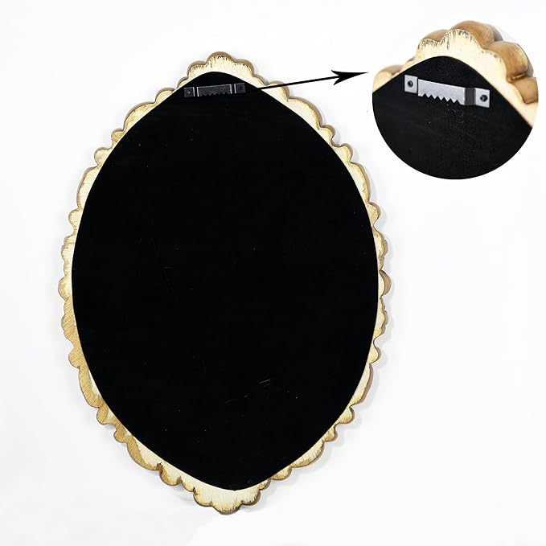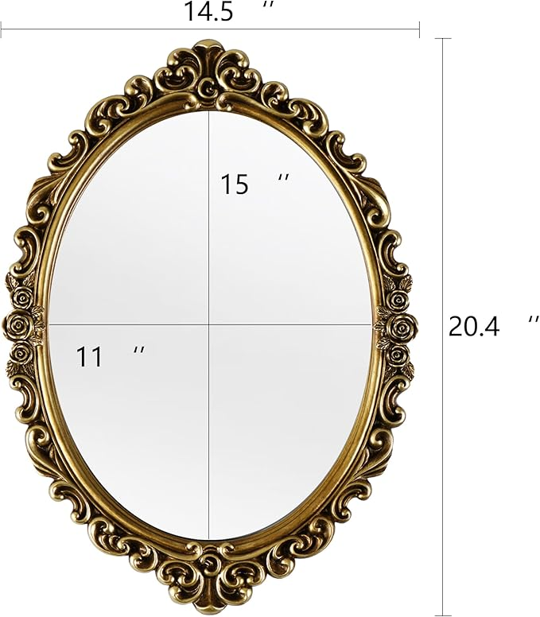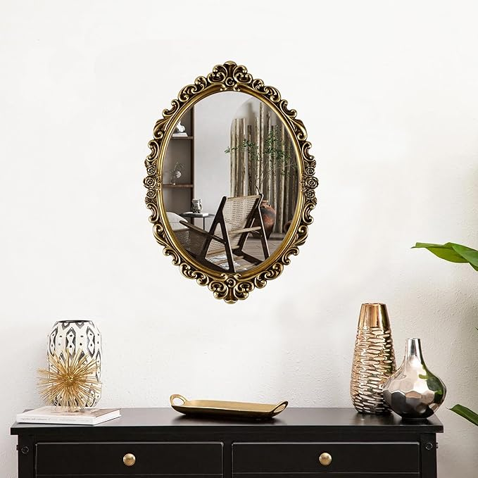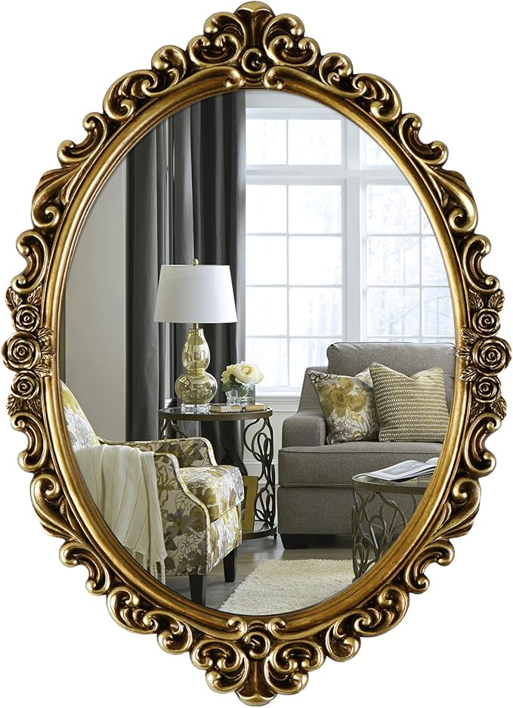

OIGUMR Oval Wall Mirror Mirror Vintage Hanging Mirrors for Bedroom Living-Room Dresser Decor (Gold；Frame Size：20.4 x 14.5 inch)

**PRODUCT DESCRIPTION:**

|  |  |
| --- | --- |
| Brand | OIGUMR |
| Room Type | Living Room Bedroom |
| Shape | Oval |
| Product Dimensions | 20.4"L x 14.5"W |
| Frame Material | Resin |

**About this item**

* Resin Frame Vintage Oval Mirror
* Oval Mirror is an excellent choice for Baroque Rococo and any other antique decor，is perfect wall decor for living room, bedroom, hallway, lounge and office
* GOLD COLOR This Gold Oval mirrors measure 20.4 x 14.5 inch and are a Vintage golden color so they suit a range of color home decor，ideal for styling your home
* Multifunctional： Vintage Oval mirror it's also a tray for perfume or makeup!
* Gift Idea - The Vintage Oval Mirror will be a perfect gift for House warming, Wedding, Anniversary, Christmas, New Year!